

MATHEMATICS 3AMAT/3BMAT SAMPLE EXAMINATION

RESOURCE-RICH
This sample examination paper was developed early 2007 and distributed to all Mathematics teachers as part of the formal consultation process (April–May 2007). The purpose was to provide teachers with an example of how the course syllabus could be examined—specifically the scope, style and difficulty level of the questions that might be asked in a typical Mathematics 3A/3B WACE examination. The sample paper has been further refined following the consultation with teachers, measurement specialists and advice from the Assessment, Review and Moderation (ARM) panel.

The sample paper has been further refined following consultation with teachers, measurement specialists and advice from the Assessment, Review and Moderation (ARM) panel. The major change is that the paper has been divided into two parts—a resource-free examination of 50 minutes, worth 40 marks, and a resource-rich examination of 100 minutes, worth 80 marks.

0000.doc




Western Australian Certificate of Education, Sample External Examination
Question/Answer Booklet

MATHEMATICS
3AMAT/3BMAT
Please place one of your student identification labels in this box.
WRITTEN PAPER
RESOURCE-RICH

Time allowed for this paper
Reading time before commencing work: Ten minutes
Working time for paper: One hour and forty minutes

Material required/recommended for this paper

To be completed by candidates

What kind(s) of calculator did you bring to this examination?

Make and model:
1.

2.
None  (tick if applicable)

To be provided by the supervisor
This Question/Answer Booklet

To be provided by the candidate
Standard items: Pens, pencils, eraser, correction fluid, ruler,
highlighter

Special items: Curriculum Council Mathematical Formulae and Statistical Tables Book, drawing instruments, templates, notes on TWO unfolded sheets of A4 paper and calculators satisfying the conditions set by the Curriculum Council for this subject.
Note: Personal copies of the Tables Book should not contain any handwritten or typewritten notes, symbols, signs, formulae or any other marks (including underlining and highlighting) except a name and address, and may be inspected during the examination.

Important note to candidates
No other items may be taken into the examination room. It is your responsibility to ensure that you do not have any unauthorised notes or other items of a non-personal nature in the examination room. If you have any unauthorised material with you, hand it to the supervisor before reading any further.

This paper is for students who have completed Units 3AMAT and 3BMAT as their last pair of units.
Structure of this paper

Working time | Number of questions available | Number of questions to be attempted | Marks
1 hour 40 minutes | 10 | 10 | 80
 |  | [Total marks] | 80

This paper has TEN (10) questions. Attempt ALL questions.

Question | Marks
1 | 8
2 | 7
3 | 7
4 | 7
5 | 7
6 | 6
7 | 8
8 | 15
9 | 8
10 | 7
Total marks | 80

Instructions to candidates

1. The rules for the conduct of Curriculum Council examinations are detailed in the Student Information Handbook. Sitting this examination implies that you agree to abide by these rules.

2. Write your answers in the spaces provided in this Question/Answer Booklet. Spare pages may be found at the end of the booklet. If you need to use them, indicate in the original answer space where the answer is continued (i.e. give the page number).

3. A blue or black ballpoint or ink pen should be used.

4. It is recommended that you do not use pencil except in diagrams.

5. Show all your working clearly. Your working should be in sufficient detail to allow your answers to be checked readily and for marks to be awarded for reasoning. Correct answers given without supporting reasoning may not be allocated full marks. Incorrect answers given without supporting reasoning cannot be allocated any marks. If you repeat an answer to any question, ensure that you cancel the answer you do not wish to have marked

6. On the front cover you are asked to state the kinds of calculator that you brought into the examination. This information is required to ensure the examination is fair for all students. Please complete the box. Note that the same marking procedure will apply to all scripts, whatever calculator you use.
RESOURCE-RICH

This paper has TEN (10) questions. Attempt ALL questions.

Question 1 [8 marks]
A sample of 200 adults was surveyed about a proposal to limit probationary drivers to the use of four-cylinder cars. Seventy of the 106 females surveyed were in favour of the proposal and five were undecided. A total of 121 adults were in favour and forty males were against the proposal.

- Display the data in the table below, then complete the table.
[2 marks]

 | In favour | Against | Undecided | Total
Male
Female
Total

- If an adult from the survey is chosen at random, find the probability that this adult:
(i) is a male in favour of the proposal.
[1 mark]

(ii) is a male, given the adult is against the proposal.
[2 marks]

- If a male is chosen at random from the male group surveyed and a female is chosen at random from the female group surveyed, who is more likely to be in favour of the proposal? Justify your answer.
[3 marks]

Question 2 [7 marks]
Use the diagram below to answer the following questions:
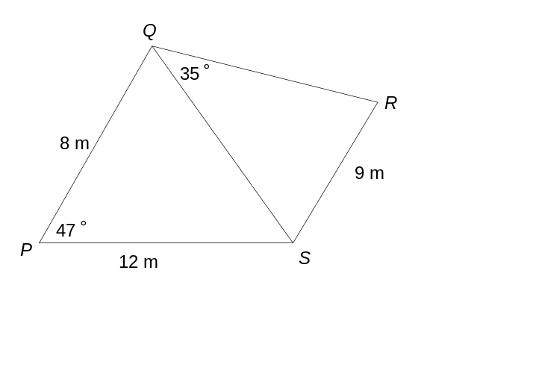

- Determine the length of QS.
[3 marks]

- Given that angle R is acute, determine the size of angle QRS.
[2 marks]

- Determine the area of quadrilateral PQRS.
[2 marks]

Question 3 [7 marks]
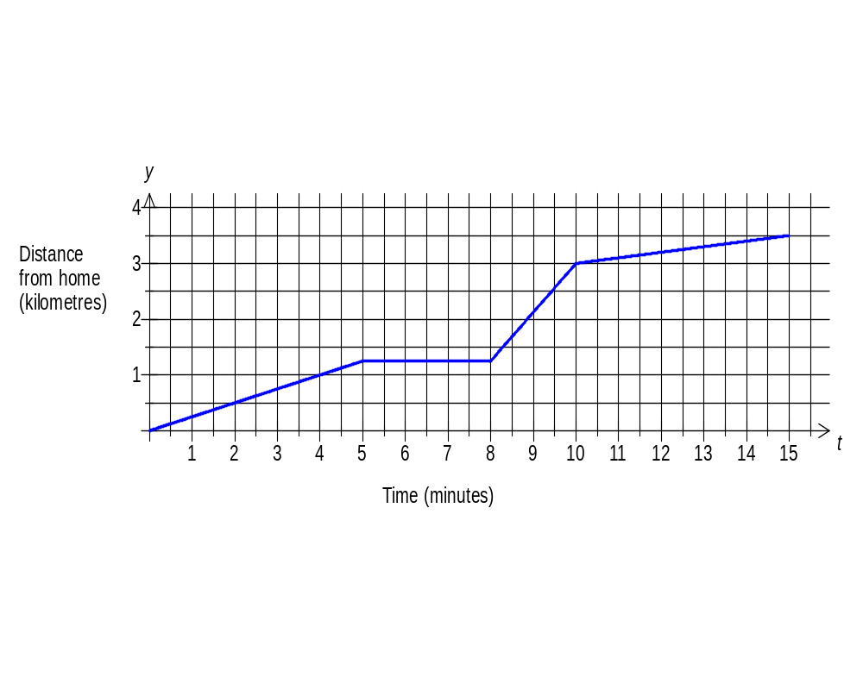Kim rode her bicycle to her friend’s place. After a brief stop, her friend’s father gave them both a lift in his car to a point near their school. They then walked the final distance to school. The graph below represents their journey:

- Determine Kim’s bicycle riding speed in metres per second.
[2 marks]

- Determine the speed of the car in kilometres per hour.
[2 marks]

- If Kim had ridden her bicycle all the way to school at the same speed as in the first leg of the trip, would she have arrived at school earlier, later or at the same time? Justify your answer.
[3 marks]

Question 4 [7 marks]
The table below shows the tasks required to complete a job:

Task | A | B | C | D | E | F | G | H | I | J
Immediate  Predecessor | - | - | A | A | B | C | C | D | G,H,E | F,I
Time (days) | 6 | 8 | 3 | 5 | 5 | 5 | 4 | 4 | 2 | 4

- Draw a project network which satisfies the above conditions.
[3 marks]

- Determine the minimum time to complete the project and state the critical path, if all tasks are completed on time.
[2 marks]

- If Task C were delayed by 3 days, what effect, if any, would this have on the completion time?
[1 mark]

- If Task D were shortened by 3 days, what effect, if any, would this have on the completion time?
[1 mark]

Question 5 [7 marks]
The table below shows the scores of the students at a large school in the Semester One, Mathematics 3A examination.

Score on Maths 3A exam (%) | 11–20 | 21–30 | 31–40 | 41–50 | 51–60 | 61–70 | 71–80 | 81–90 | 91–100
Number of students | 2 | 4 | 7 | 8 | 15 | 25 | 29 | 20 | 9

(a) How many students sat for the examination?
[1 mark]

(b) Describe student performance in the examination.
[6 marks]

Question 6 [6 marks]
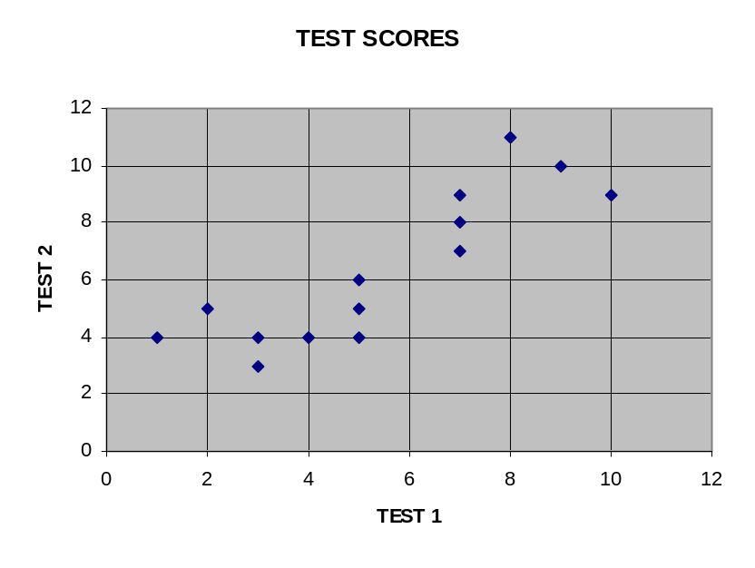The graph below shows the results of 14 students on two tests. All marks are whole numbers.

Using all the 14 data points:
- the correlation coefficient is 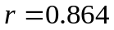 (3 d.p.) (R1)
- the equation of the line of regression is 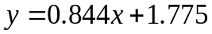 (3 d.p.) (L1)

When the two data points with the lowest scores on Test 1 and the two data points with highest scores on Test 1 are removed
- the correlation coefficient is 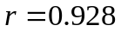 (3 d.p.) (R2)
- the equation of the line of regression is 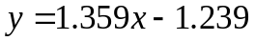 (3 d.p.) (L2)

(a) (i) Use the more appropriate of the two lines of regression to estimate the mark on Test 2 for a student who scored 4 on Test 1.
[1 mark]

(ii) Justify why you used that particular line of regression and comment on the reliability of your prediction.
[2 marks]

(b) (i) Use the more appropriate of the two lines of regression to estimate the mark on Test 2 for a student who scored 11 on Test 1.
[1 mark]

(ii) Justify why you used that particular line of regression and comment on the reliability of your prediction.
[2 marks]

THIS SPACE HAS BEEN LEFT BLANK INTENTIONALLY

Question 7 [8 marks]
A farmer wishes to create a holding pen by fencing off an area in the corner of a fenced paddock with 200 metres of fencing as shown in the right triangle:

200
b
h

- Show that the height, in terms of the base, is given by the equation:

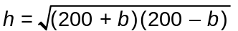
[2 marks]

- Complete the following table (to two decimal places):
[2 marks]
Base, b (m) | Height, h (m) | Area, A (m²)
90 | 178.61 | 8037.26
100
110

- Determine the maximum area. Clearly show the method used.
[4 marks]

THIS PAGE HAS BEEN LEFT BLANK INTENTIONALLY

Question 8 [15 marks]
At the beginning of 1995, the European wasp population in the Perth suburb of Waspville, was 400. It increased at a rate of 10% for 2 years.

A sterilisation program was introduced at the beginning of 1997 by the WA Department of Agriculture. As a result, the numbers decreased dramatically then increased before levelling out at a stable population 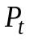, following the model:

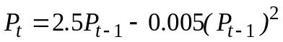 for > 2, where is in years.

- Complete the table below showing the starting population for each year from 1995 to 2007. (Note: Two values have been completed for you.)
[4 marks]
P_{t} | Year | Beginning population
P_{o} | 1995 | 400
P₁ | 1996
P₂ | 1997
P₃ | 1998 | 39
 | 1999
 | 2000
 | 2001
 | 2002
 | 2003
 | 2004
 | 2005
 | 2006
 | 2007

- Population during 1995 and 1996 can be described by:
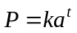

(i) What type of function is this?
[1 mark]

(ii) Give the values of k and a.
[2 marks]

(c) (i) What population size will the European wasps level out at if the sterilisation program continues?
[1 mark]

(ii) Explain mathematically why the population levels out.
[3 marks]

- Sketch the population from 1995 to beyond 2007 onto the axes below, including any important values.
[4 marks]

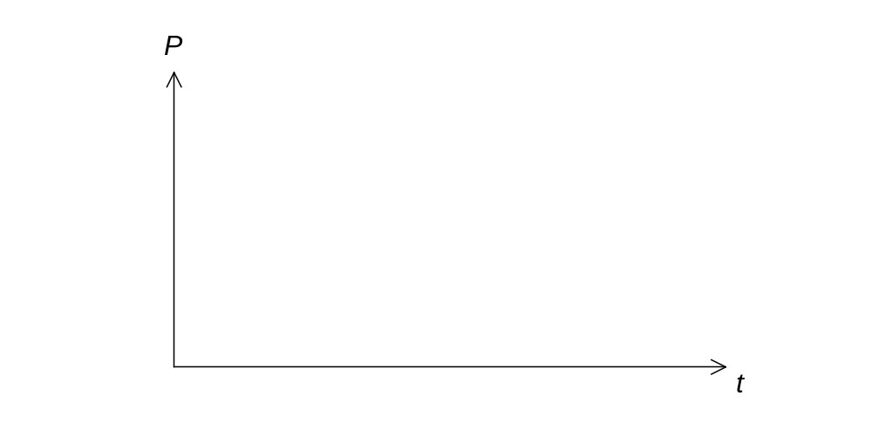

Question 9 [8 marks]
Sales at a school canteen over a four-week period are given in the table below:

Week | Day | Time  t | Sales  (in dollars) | 5-point moving average | Residual
1 | Monday | 1 | 630 | - | -
1 | Tuesday | 2 | 520 | - | -
1 | Wednesday | 3 | 530 | 566 | -36
1 | Thursday | 4 | 550 | 568 | -18
1 | Friday | 5 | 600 | 568 | 32
2 | Monday | 6 | 640 | 570 | 70
2 | Tuesday | 7 | 520 | 574 | -54
2 | Wednesday | 8 | 540 | 578 | B
2 | Thursday | 9 | 570 | 580 | -10
2 | Friday | 10 | 620 | 584 | 36
3 | Monday | 11 | 650 | 582 | 68
3 | Tuesday | 12 | 540 | 582 | -42
3 | Wednesday | 13 | 530 | 582 | -52
3 | Thursday | 14 | 570 | 584 | -14
3 | Friday | 15 | 620 | A | 36
4 | Monday | 16 | 660 | 588 | 72
4 | Tuesday | 17 | 540 | 586 | -46
4 | Wednesday | 18 | 550 | 588 | -38
4 | Thursday | 19 | 560 | - | -
4 | Friday | 20 | 630 | - | -

- Calculate the values in the cells denoted by A and B.
[2 marks]

- The equation of the trend line for the moving averages is 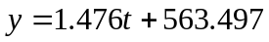
(with correlation r ≈ 0.944). Predict the sales (to the nearest 50 cents) for Monday of Week 5.
[3 marks]

- Comment on the reliability of your prediction in (b), using mathematical reasoning.
[2 marks]

- Comment on the reliability of your prediction in (b), in terms of the context.
[1 mark]

Question 10 [7 marks]
The scores in a Chemistry Examination (maximum mark 200) were normally distributed with a mean of 124 marks and a standard deviation of 30 marks.

- What proportion of students scored less than 100 marks?
[2 marks]

- The top 2% of students were awarded a certificate of distinction. What minimum mark was needed for a certificate of distinction?
[2 marks]

- The middle 40% of students received a grade of C. What were the minimum and maximum marks in order for a student to be awarded a C?
[3 marks]

ACKNOWLEDGEMENTS

Published by the Curriculum Council of Western Australia
27 Walters Drive
OSBORNE PARK WA 6017

